## Step One: Define the Problem

### Define the problem

The problem is to create a program for the client ‘Nikki Nacks’ to automate their services. The reason they need this done because most of their operations are outdated and even dangerous for privacy reasons. The outcome of the program is to operate and function like a small store. The information obtained from the user would be name, age, email, phone number and the amount of money being spent. The details about the user would be categorised into a user account with the credit card/s linked to it. The card credit details will be used to verify purchase, then allow the user to download the product. The money being spent will checked and verify, that the correct amount is true allowing the user gain access to the product.

### Is there any starting data or legacy data?

These are all the variables you get from the legacy data, with one table shown below with data.

Please refer to JSON file that was provided with this project to see more details.

|  |  |
| --- | --- |
| productID | 001 |
| productName | Oblivion |
| productType | Movie |
| newRelease | True |
| productPrice | 6.50 |

## Step Two: Consider the inputs/outputs

### Describe the inputs

#### Input Screen

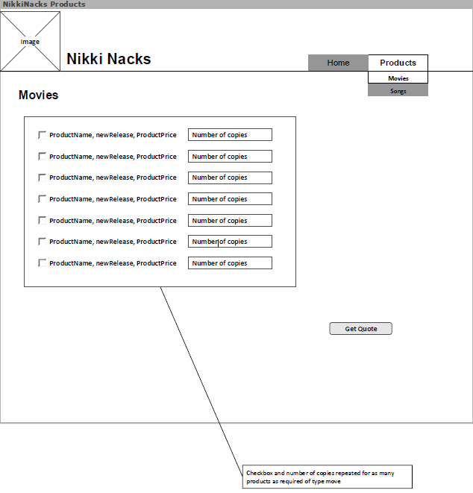

#### Inputs

|  |
| --- |
| **Inputs** |
| Quantity |

### Describe the output

#### Output Screen

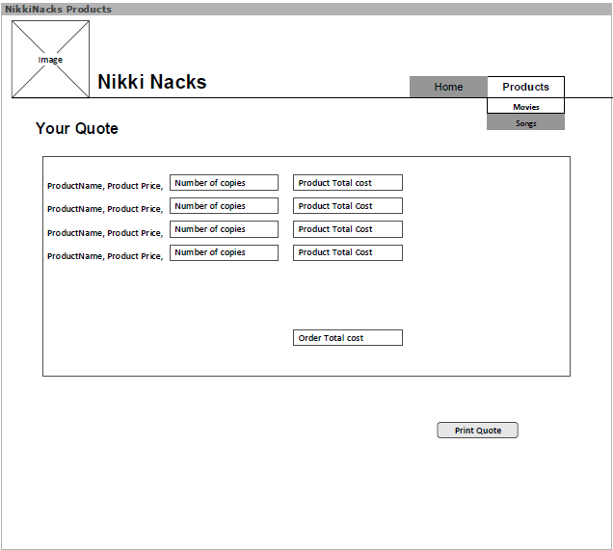

#### Outputs

|  |
| --- |
| **Outputs** |
| OrderCost (all ProductCostTotals added together) |
| ProductTotalCost (product cost * quantity) |

## Step Three: Outline what processing might be required

### Label the processes or steps

#### Processes

|  |
| --- |
| **Processes** |
| Initialise Variables |
| Calculate ProductCostTotal |
| Calculate OrderTotal |
| Check what units are checked (Ticked) |
| Print quote |

#### Pseudo Code

START

INITALISE Variables

Select type of Product

DISPLAY products

IF not ready to print

SELECT product

ENTER Quantity

GET Quote

ELSE

PRINT Quote

ENDIF

END

### Design the flow

#### C:\Users\cosim\AppData\Local\Microsoft\Windows\INetCache\Content.Word\AssessmentOneREUPDATEDagain (1) (1).pngFlowchart

## Step Four: Develop the algorithm

### Specifying real calculations

#### Initialise variables

These are all the variables that are initialised, with one table shown below with data.

The legacy data is a table from JSON that is going to be use in the application. Please refer to JSON file that was provided with this project to see more details.

|  |  |
| --- | --- |
| (String)Qty | “0” |
| (INT)Quantity | 0 |
| ProductCostTotal | 0 |
| OrderTotal | 0 |
| productID | Product ID |
| productName | Product Name |
| productType | Product Type |
| newRelease | New Release |
| productPrice | Price |

#### Calculate OrderTotal

* Input Qty
* Qty = parseInt(Quantity)
* OrderTotal = OrderTotal + (productPrice*Quantity)

Or

* Input Qty
* Qty = parseInt(Quantity)
* Calculate ProductCostTotal = productPrice * Quantity
* OrderTotal += ProductCostTotal

### Making code

#### Algorithm

Start

Variables are ready to use

Choose either songs or movies

Products are displayed

If you are not ready to print quote

Select a product you want

Them you input the number of copies you want of this product

Quantity is converted

Calculate ProductCostTotal for each row (productPrice * Quantity)

Calculate OrderTotal (all ProductCostTotals added together)

Print only units that are checked

End

## Step Five: Test the algorithm

### Test the code

**Consider what will happen when your program is finished. You will need to make sure that what was considered in the design phase is actually what was developed. The test cases are written at the beginning of the process so that we can compare the expected outcome with the actual outcome. The tester will fill in their name and ID as well as the Actual columns when they complete the tests.**

* **Test Number: A numeric test case reference**
* **Description: An overview of what the test case will actually test**
* **Test Instructions: A step-by-step guide on what the tester needs to do**
* **Input Data: What, if anything, the tester needs to type in**
* **Expected: What the outcome should be**

|  |  |  |  |  |  |
| --- | --- | --- | --- | --- | --- |
| Test Information | | **Tester:** Cosimo Ricupero | | **Tester ID:** 041114567 | |
| **Test Ref.** | **Description** | **Test Instructions** | **Input Data** | **Expected** | **Actual** |
| 1.0 | Run the Application | Click run to start app | N/A | Application opens and Home page is displayed |  |
| 2.0 | Display Songs menu | Select Songs in the (Products) combo box | N/A | Songs menu is displayed |  |
| 2.1 | Display Movies menu | Select Movies in the (Products) combo box | N/A | Movies menu is displayed |  |
| 2.2 | Display Songs Menu from the Movies Menu | Select Movies in the (Products) combo box while on the Songs Menu | N/A | Songs menu is displayed |  |
| 2.3 | Display Movies Menu from the Songs Menu | Select Songs in the (Products) combo box while on the Movies Menu | N/A | Movies menu is displayed |  |
| 2.4 | Display home page from the song menu | Select the Home button at the top | N/A | Home page is displayed |  |
| 2.5 | Display Home page from the movies menu | Select the Home button at the top | N/A | Home page is displayed |  |
| 3.0 | Select a song | Tick a checkbox of a song | N/A | The checkbox is ticked |  |
| 3.1 | Select a movie | Tick a checkbox of a movie | N/A | The checkbox is ticked |  |
| 3.2 | Unselect a product | Untick a checkbox of a product | N/A | The checkbox is unticked |  |
| 4.0 | Input data | Type data into field with keyboard | 1 | 1 |  |
| 4.1 | Input data | Type data into field with keyboard | 0 | 0 |  |
| 4.2 | Input data | Type data into field with keyboard | 9999 | 9999 |  |
| 4.3 | Input data | Type data into field with keyboard | 0000 | 0000 |  |
| 4.4 | Input data | Type data into field with keyboard | Five | Error |  |
| 4.5 | Input data | Type data into field with keyboard | @#$* | Error |  |
| 4.6 | Input data | Type data into field with keyboard | 57684454 | 57684454 |  |
| 5.0 | Print Quote | Click the button ‘Print’ with mouse | N/A | Process is successful |  |
| 5.1 | Get Quote | Click the button ‘Get’ with mouse | N/A | Process is successful |  |